**How-To Upgrade Citrix Tools for Windows Virtual Machines**

This article explains how to upgrade the Citrix Tools for Virtual Machines on Windows cloud servers. The Citrix tools are fundamental to the proper operation of virtualized cloud servers in our cloud infrastructure. They are the underlying drivers for the virtual machine, giving it access to virtual hardware specifically networking, and block devices. These tools should ONLY be touched if the Windows server is having issues with Blue Screens of Death (BSoD), or if Cloud Support has recommended upgrading the tools. Version information can be found in Programs and Features.

|  |
| --- |
| **WARNING** – BY PERFORMING THE STEPS OUTLINED IN THIS ARTICLE, YOU WILL INCUR NETWORK DOWNTIME. DO NOT PERFORM THE INSTALLATION OUTLINED BELOW ON A PRODUCTION SERVER AS IT WILL RESULT IN NETWORK DISRUPTION AND MULTIPLE REBOOTS OF THE SERVER. WE CAN NOT PROMISE THAT THIS UPGRADE WILL SOLVE ALL ISSUES, HOWEVER WE HAVE FOUND IT TO MITIGATE BSoD PROBLEMS FOR SOME CUSTOMERS AFTER COMPLETING THE UPGRADE TO VERSION 6.2. |

**Important Prerequisites**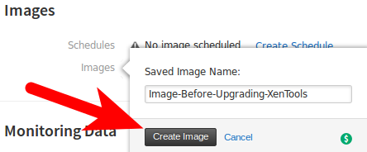 – The following files should be downloaded to the production server before beginning this tutorial.

[Citrix Tools for Virtual Machines 6.0](http://8d268c176171c62fbd4b-7084e0c7b53cce27e6cc2142114e456e.r30.cf1.rackcdn.com/xstools-6.0.zip)

[Citrix Tools for Virtual Machines 6.2](http://8d268c176171c62fbd4b-7084e0c7b53cce27e6cc2142114e456e.r30.cf1.rackcdn.com/xstools-6.2.zip)

[Cloud Servers Agent Service](http://5ef1b700b2e853350a6a-52080ce862bc0ea8ae107677959a39ad.r97.cf2.rackcdn.com/Rackspace-Cloud-Servers-Agent-Latest.zip)

**Step 1 – Image Creation & Non-Production Server Created**

1.A.) Take an image of the server to be upgraded. This process can take anywhere from less than an hour, to multiple hours to complete depending on how large your server's virtual hard drive is. If you're curious, there is more information about the imaging process [here](https://community.rackspace.com/products/f/25/t/3778).

1.B.) Using the image that is created from step 1A, create a new server, verify that it boots properly, and ensure that all data / services are intact.

1.C.) Moving forward **ALL** steps should FIRST be performed on the newly created server from step 1B; during the installation network connectivity **WILL BE IMPACTED** as we upgrade the tools.

**Step 2 – Upgrading to Xen Server Tools 6.0 on the NEW Non-Production Server.**

**\*NOTE* Step 2 can be COMPLETELY skipped if you already have** **6.0.58937** **installed. *NOTE\***

**\*TIP**\* **Stop/Disable all non-system applications/services to allow unimpeded installation. *TIP\***

2.A.) Log into your server via the console, the console will need to be used due to the fact that network connectivity will be interrupted. There are two ways to access your server's console from

the cloud control panel. The first shortcut is available through the server list, and the second is available on the server details page after clicking the, “Actions” menu.

2.B.1.) Extract the archive named xstools-6.0.zip to a local directory, e.g. C:\

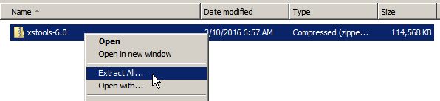

2.B.2.) Within the extracted folder, run xensetup.exe

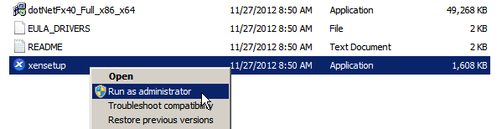

2.B.3.) Click Next.

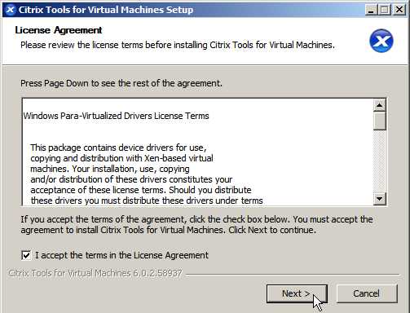

2.B.4.) Click Install (using the default destination folder is recommended).

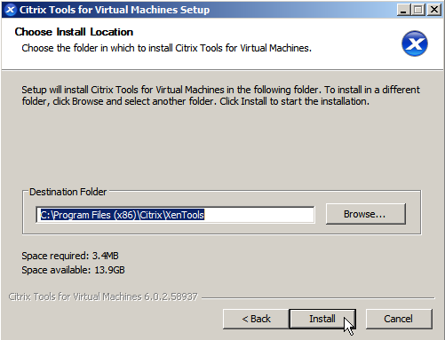

2.B.5.) Toward the end of the installation process, “Reboot Now” should be selected. Click, “Finish” to complete the installation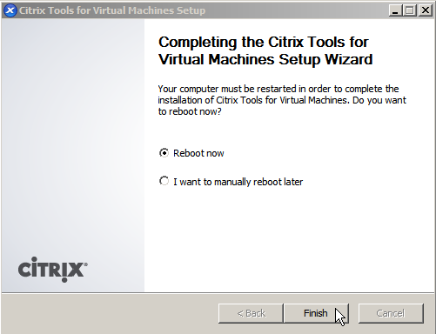, which will reboot the server.

2.C.) The installation should now be complete. Open Programs and Features (appwiz.cpl) to ensure Citrix Tools for Virtual Machines version 6.0.58937 is installed.

**Step 3 – Upgrading to Xen Server Tools 6.2 on the NEW Non-Production Server.**

3.A.) Log into your server via the console, the console will need to be used due to the fact that network connectivity will be interrupted. There are two ways to access your server's console from the cloud control panel. The first shortcut is available through the server list, and the second is available on the server details page after clicking the, “Actions” menu.

3.B.1.) Extract the archive named xstools-6.2.zip to a local directory, e.g. C:\

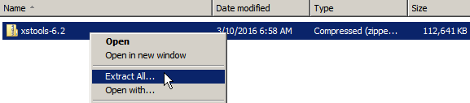3.B.2.) Within the extracted folder, double click, “installwizard”.

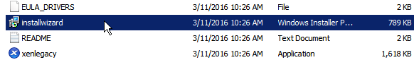3.B.3.) Click Next.

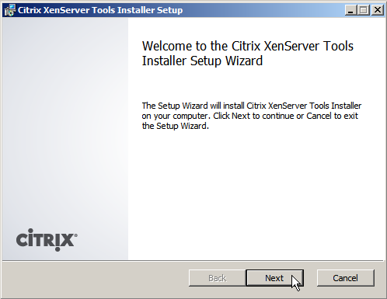

3.B.4.) Click Next Again.

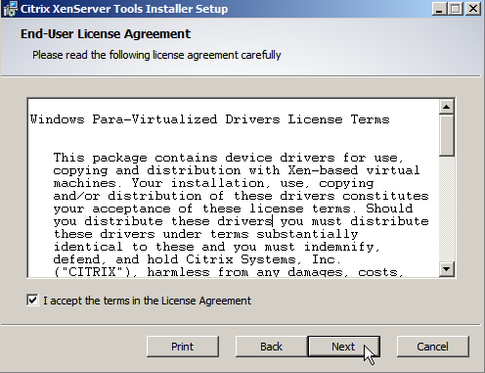

3.B.5.) Click Next (using the default folder is recommended).

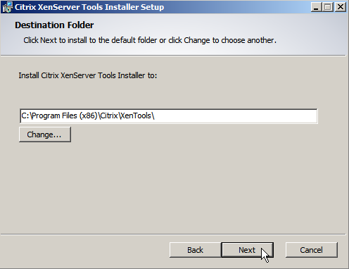

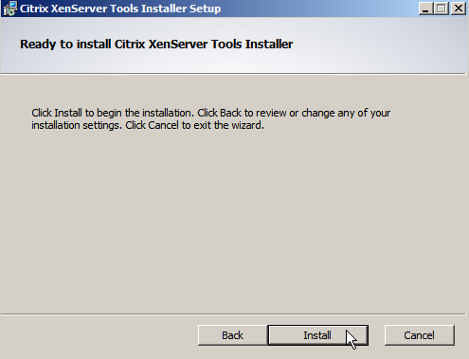3.B.6) Click, “Install” to prepare the Citrix Tools Installer.

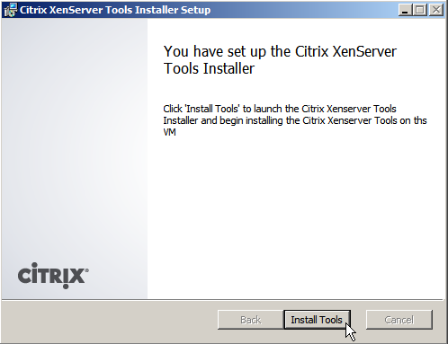3.B.7.) After the setup launches - Click, “Install Tools” to begin the installation.

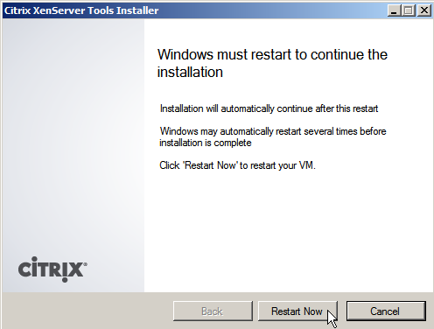3.B.8) Click, “Restart Now” to continue to the installation. Take note that the server may automatically restart several times before installation is complete.

3.C.) The installation is complete when the installer displays, “You have successfully installed the Citrix XenServer Tools. Open Programs and Features (appwiz.cpl) to verify Citrix Tools for Virtual Machines version 6.2 is installed.

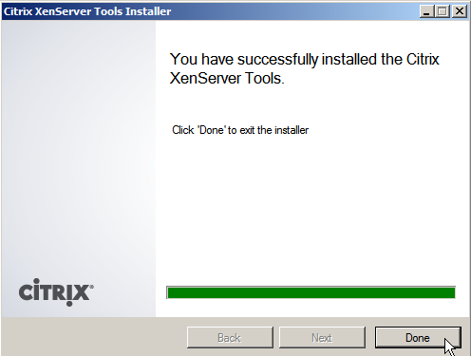

3.D.) Windows will most likely present you with a request to restart once more to apply changes after the recent installation. Restart again!

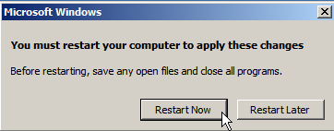

**Step 4 – Upgrading the Rackspace Cloud Servers Agent.**

**Optional method of installation:** If the server has an active connection to the INTERNET, start a command prompt as an administrator and run the following, “one-liner” to easily install the agent in an unattended fashion.

|  |
| --- |
| powershell.exe -NoProfile -ExecutionPolicy unrestricted -Command (New-Object Net.WebClient).DownloadFile('http://5ef1b700b2e853350a6a-52080ce862bc0ea8ae107677959a39ad.r97.cf2.rackcdn.com/Rackspace-Cloud-Servers-Agent-Installer-Latest.bat', '%tmp%\Rackspace-Cloud-Servers-Agent-Installer-Latest.bat') & %tmp%\Rackspace-Cloud-Servers-Agent-Installer-Latest.bat |

**Offline method of installation:**

4.A.) Extract the archive named, “Rackspace-Cloud-Servers-Agent-Latest.zip”.

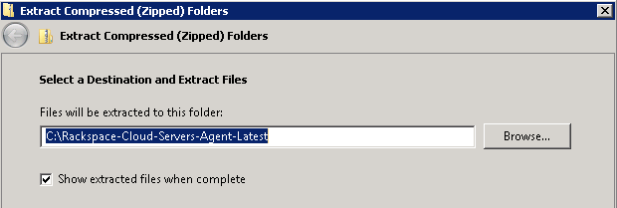

# 4.B.) Within the extracted folder, right click the, "Agent-Services-Install-OR-Upgrade" batch file and choose, "Run as administrator". The script will automatically update the agent.

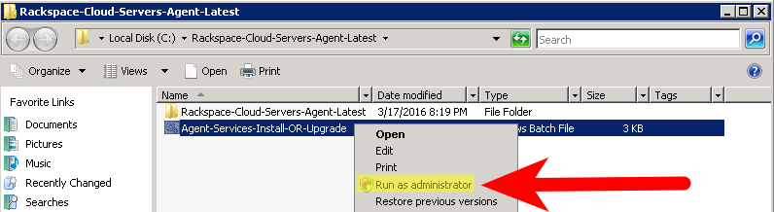

**Step 5 – Decide which server to keep.**

After performing the aforementioned steps on the NEW server, decide if you'd like to keep it, or abandon it. See below for the options that are available moving forward.

**Option 1:** Now that the new server contains the updated Citrix Tools for Virtual Machines, and Rackspace Cloud Servers Agent - it may be close to ready for production use.

Option one involves deleting the original server, and contined use of the NEW server. This option will usually be the quickest, and easiest to abide by. One notable caveat is that the IP address will be different, and there is not a way for Rackspace support to transfer the original server's IP address to the new server. This can be mitigated if [Cloud Load Balancers](https://www.rackspace.com/cloud/load-balancing) have been in use. If a load balancer(s) was already being used, simply remove the original server (node) from the load balancer, then add the new one.

Before deleting the original server, be certain **ALL IMPORTANT DATA** has been properly restored to the new server. This includes any data that may reside on an ephermeral disk drive which **is not included in the image of the original server**. If you are not sure what an ephemeral drive is, see [here](https://developer.rackspace.com/docs/user-guides/infrastructure/cloud-config/compute/cloud-servers-product-concepts/diskconfig/). If you are still uncertain, please contact Rackspace support for further guidance.

If the original server does have ephemeral storage, there are a number of ways to migrate the data to the new server. If both servers have a service network IP you can use file sharing built into Windows. Alternatively you could use FTP, FTPS, or use our [cloud backup agent](https://support.rackspace.com/how-to/cloud-backup/) for cloud servers which can be installed on both Windows, and Linux instances. An additonal fast/easy method to transfer data between servers (especially if there is a lot) includes adding [Cloud Block Storage](https://www.rackspace.com/en-us/cloud/block-storage) to the original server. Copy the needed data to the newly created and attached volume, detach it from the original server, and then reattach the volume to the new server where the ephemeral drive had been mounted before, e.g. D:\.

Helpful Cloud Block Storage links:

[Overview of CBS](https://support.rackspace.com/how-to/cloud-block-storage-overview/) | [Prepare your CBS volume](https://support.rackspace.com/how-to/prepare-your-cloud-block-storage-volume/) | [FAQ about CBS](https://support.rackspace.com/how-to/cloud-block-storage-faq/)

If this option is utilized, we recommend taking a final image of the server which can then be used as a base image to create new servers, or rebuild the current server if needed in the future.

**Option 2:** Perform all of the previous steps on the production server during a planned maintenance window. *The Server retains its original IP addres in this step.*

After installing the tools on the duplicate server, you should have a better understanding of the length of time it took to install them which makes planning a maintenance window much easier. *It is important to note that having proper backups is recommended before starting this process a second time on the production server.* It is preferrable to have both an image, and file level backups of all important content on the server. This is still essential because while the previously built "NEW" server should still be accessible and contain a nearly identical root file system of the original server, it is always strongly recommended to have multiple backups in the event of failure. As previously mentioned, we offer a [backup agent](https://support.rackspace.com/how-to/cloud-backup/) for cloud servers which can be installed on both Windows, and Linux cloud server instances.

**Option 3:** Rebuild the production server from an image of the NEW server. *The server retains its original IP address in this step.*

**Before proceeding**: We strongly recommend having "proper backups" as outlined in **Options 1 & 2**.

This last option may take the most amount of time to complete; the length of time from start to finish is dependant on how large your NEW server's virtual hard drive is. Begin by taking an image of the NEW server and wait for it to complete. Navigate to the original server's details page. On the details page, there is an option named, "Rebuild..." directly under the server's **UUID** (Universal Unique Identifier). A new window will appear on the page. Select the, "Saved" tab to view your saved images. Then choose the recently created image – the process begin just yet.

|  |
| --- |
| Warning: Rebuilding will destroy all data on your original server and install the image you select. |

If you are ready to commit to the rebuilding of this server, proceed by clicking, "Rebuild Server" which will begin the process. The duration of the rebuild may take just as long as the imaging process.